AZƏRBAYCAN RESPUBLİKASI TƏHSİL NAZİRLİYİ

Bakı Mühəndislik Universiteti

**Fakultə**: Mühəndislik

**Kafedra**: Kompüter və İnformasiya Texnologiyaları

**İxtisas**: Informasiya Texnologiyaları

Hesabat qəbul edilir:

Qiymət (bal)

Kafedranın baş müəllimi

Həsənov Əli Vahid



**Fənn: *<<*** Computer Algorithms ***>>***

Kurs İşi

***<<*** Problem with combinatorics and solutions ***>>***

**Hesabat**

3 kurs tələbəsi Maqsudov Nihad



**BMU-2022**

I What is the **Combinatorics**? ..………………………….……… 3 – 4

II Where do we use combinatorics in our life ………………………… 5

III Some problems related to combinatorics and their solution in different ways.………………………… 5-12

III.I Example ………………………… 5-6

III.II Overlapping Subproblems ……………….

III.III Optimal Substructure ……………….



**What is the Combinatorics?**

**Combinatorics** is a stream of mathematics that concerns the study of finite discrete structures. It deals with the study of permutations and combinations, enumerations of the sets of elements. It characterizes Mathematical relations and their properties.

Mathematicians uses the term “Combinatorics” as it refers to the larger subset of Discrete Mathematics.  It is frequently used in computer Science to derive the formulas and it is used for the estimation of the analysis of the algorithms. In this article, let us discuss what is combinatorics, its features, formulas, applications and examples in detail.

## **Features of combinatorics**

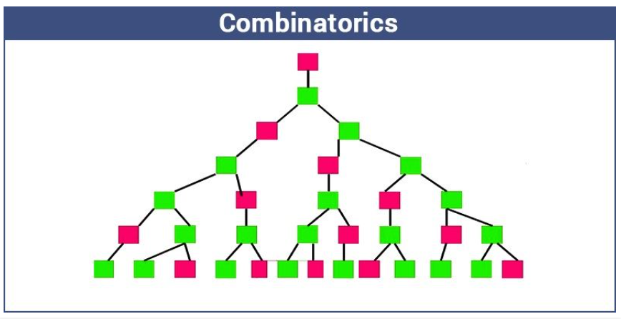

Some of the important features of the combinatorics are as follows:

* Counting the structures of the provided kind and size.
* To decide when particular criteria can be fulfilled and analyzing elements of the criteria, such as combinatorial designs.
* To identify “greatest”, “smallest” or “optimal” elements, known as external combinatorics.

Combinatorial structures that rise in an algebraic concept, or applying algebraic techniques to combinatorial problems, known as algebraic combinatorics.

Let’s talk about combinatorics: 1. Permutation, 2. Combination, 3. Enumeration

1.Permutation - The act of an arranging all the members of a set into some order or sequence, or rearranging the ordered set, is called the process of permutation. Mathematically Permutation is given as k-permutation of n is:



2.Combination - Selection of members of the set where the order is disregarded. k-combination of n is:



3.Enumeration - An enumeration is a complete, ordered listing of all the items in a collection. The term is commonly used in mathematics and computer science to refer to a listing of all of the elements of a set. Mathematically Permutation is given like that:

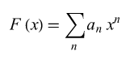



**Where do we use combinatorics in our life?**

Combinatorics is applied in most of the areas such as:

* Communication networks, cryptography and network security
* Computational molecular biology
* Computer architecture
* Scientific discovery
* Languages
* Pattern analysis
* Simulation
* Databases and data mining
* Homeland security
* Operations research

**Some problems related to combinatorics and their solution in different ways.**

A permutation, also called an “arrangement number” or “order”, is a rearrangement of the elements of an ordered list S into a one-to-one correspondence with S itself. A string of length n has n! permutation.

**Solving**  
std::rotate function rotates elements of a vector/string such that the passed middle element becomes first. For example, if we call rotate for “ABCD” with middle as second element, the string becomes “BCDA” and if we again call rotate with middle as second element, the string becomes “CDAB”.

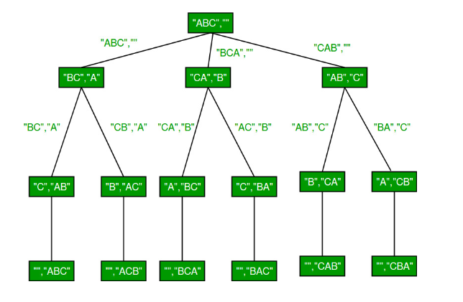

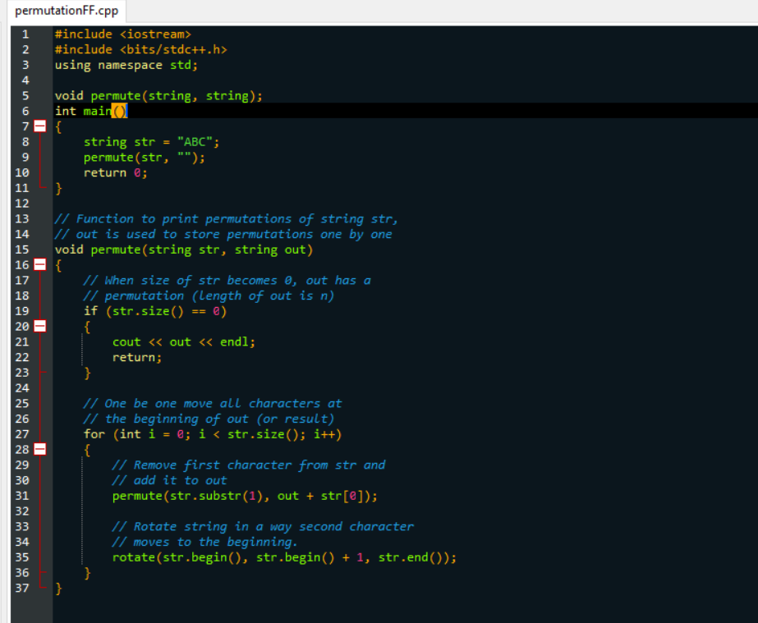

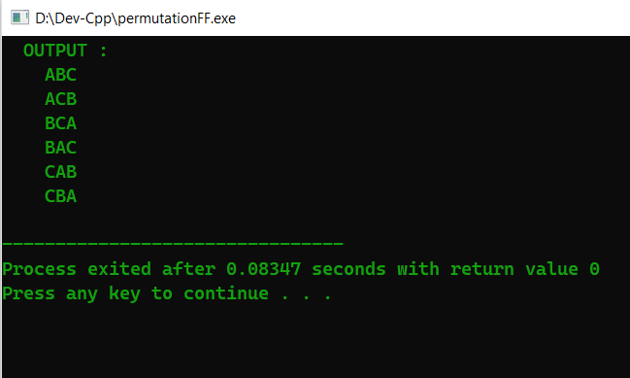

Now l will write a program that takes two parameters m and n, and returns the number of combinations of r (Binomial coefficient) C (m, n). But first of all, l wants to show something before starting write a program.

**Properties of a problem that suggests a given problem can be solved using DP:**

If any problem is having the following two properties, then it can be solved using DP:

* Overlapping Subproblems
* Optimal Substructure

**Overlapping Subproblems**

Dynamic Programming is used where solutions of the same subproblems are needed again and again. In dynamic programming pre-computed results of sub-problems are stored in a lookup table to avoid computing same sub-problem again and again. So Dynamic Programming is not useful when there are no overlapping(common) subproblems because there is no need to store results if they are not needed again and again.



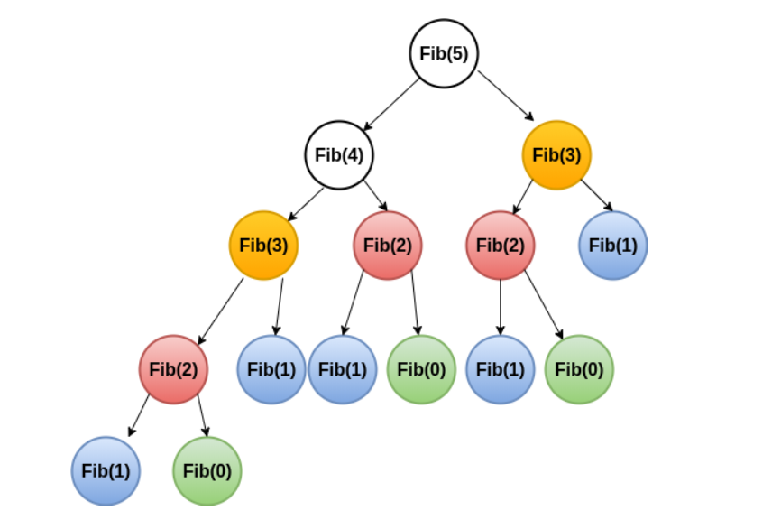

From the above diagram, it can be shown that Fib (3) is calculated 2 times, Fib (2) is calculated 3 times and so on.

**Optimal Substructure**

A problem has an optimal substructure property if an optimal solution of the given problem can be obtained by using the optimal solution of its subproblems. Dynamic Programming takes advantage of this property to find a solution.



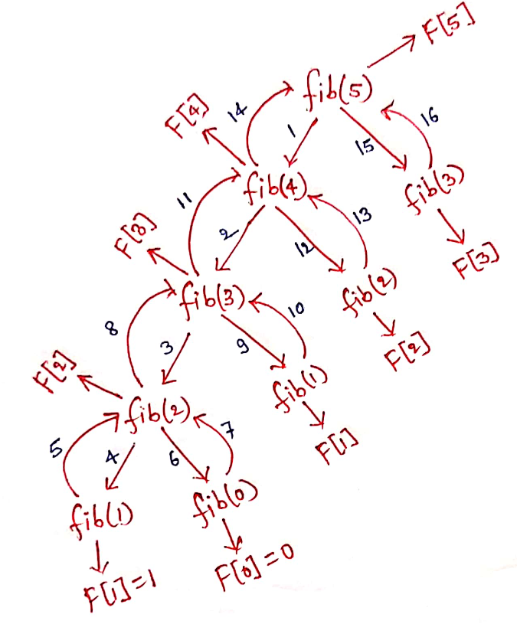

In the above example of Fibonacci Number, for the optimal solution of Nth Fibonacci number, we need the optimal solution of (N-1) th Fibonacci number and (N-2) th Fibonacci number.

In now l will use Optimal Substructure for solving this problem. The value of C (n, k) can be recursively calculated using the following standard formula for Binomial Coefficients.

C (m, n) = C (m-1, n-1) + C (m-1, n)

C (m, 0) = C (m, m) = 1

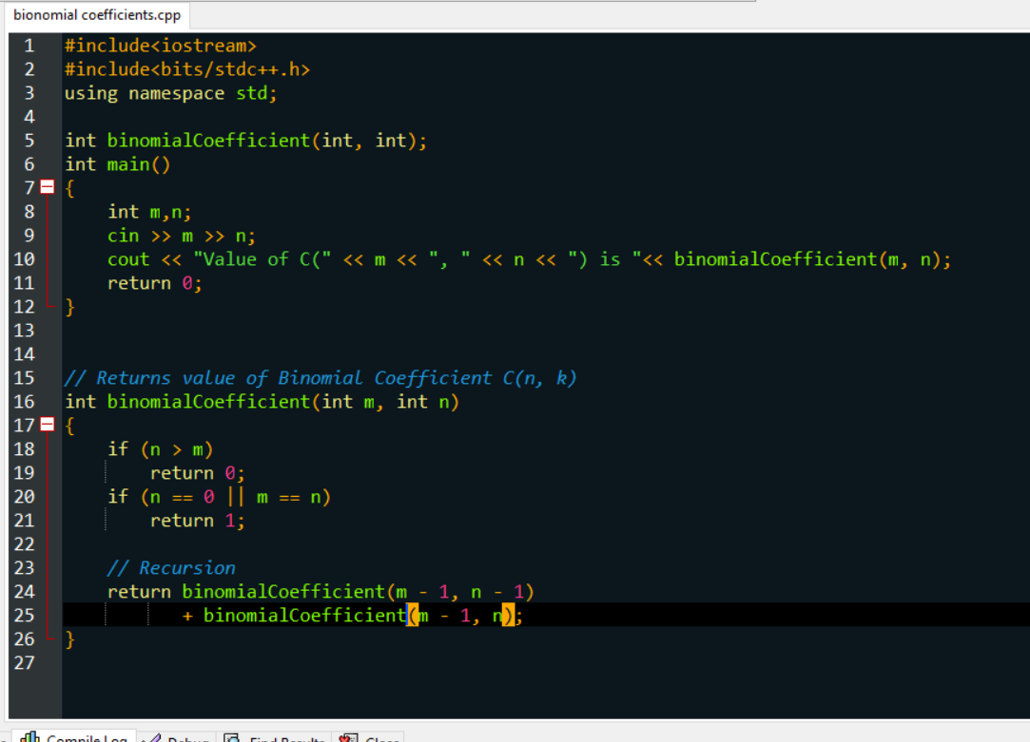

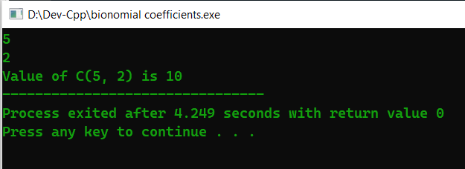

**Another Approach: (Modular Inversion technique)**

 The general formula of nCr is (n*(n-1) * (n-2) * … * (n-r+1)) / (r!). We can directly use this formula to find nCr. But that will overflow out of bound. We need to find nCr mod m so that it doesn’t overflow. We can easily do it with modular arithmetic formula.

for the n*(n-1) * (n-2) * ... * (n-r+1) part we can use the formula,

(a*b) mod m = ((a % m) * (b % m)) % m

inv [1] = 1

inv[i] = − ⌊m/i⌋ * inv [m mod i] mod m 🡺 To use this formula, m has to be a prime. 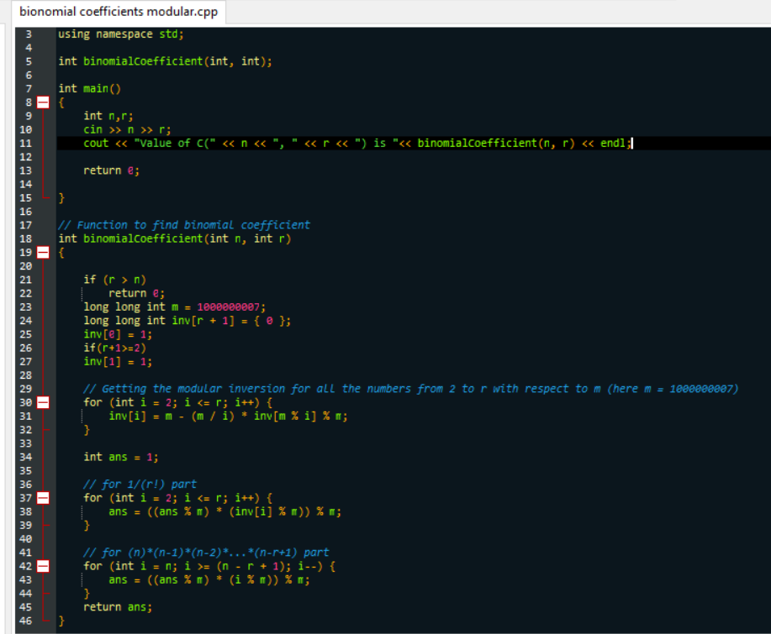



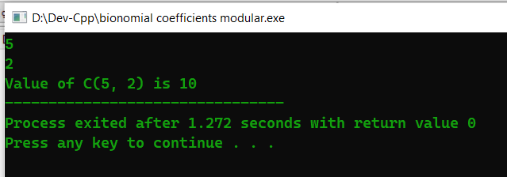

After these processes were finished, we saw that the second method exited in less time than the first method we used.

Conclusion:

Combinatorics is used in a vast array of fields, from natural sciences such as physics, chemistry, and biology, to practically oriented disciplines such as computer science, statistics, and finance. It is a unique science in the way it offers methods that can significantly boost research in a wide spectrum of areas. The possibilities that have been opened by combinatorial approaches to existing problems have drastically improved many aspects of human life. Its impact on computer science laid the foundation for all other progress, as it resulted in the creation of more powerful software and hardware that is used in other fields. The latest research in chemistry, and specifically the pharmaceutical sector, has allowed people to live longer and healthier lives. Combinatorial biology has made numerous discoveries in gene modification, which have had a major positive effect on the agriculture industry. Finally, the use of combinatorics in finance is driving the economic development of the modern world.

The current achievements of combinatorics in other fields are remarkable, however, this sector likely has greater potential. The most promising application of combinatorics is in quantum physics, due to the fact that this field offers something that is principally different from every other tool available to humanity. Quantum computing is currently in the very initial stage of development and has little practical value. With time, it will be able to assist people with tasks that traditional computers cannot solve in any amount of time. It is also likely to open access to new research areas that are currently outside of most people’s comprehension. The inevitable leap in computational technology will cause breakthroughs in other fields, which would in turn yield global quality of life improvements. While combinatorics may not be at the forefront of all innovation, it is a powerful and versatile tool that serves as a driving force of progress in key areas. Its impact on the world we live in is not obvious, but it should not be underestimated.

References:

1. <https://mathigon.org/world/Combinatorics>
2. <https://www.quora.com/What-are-some-practical-applications-of-Combinatorics>
3. <https://collegedunia.com/exams/combinatorics-definition-formula-features-applications-and-solved-examples-articleid-4640>
4. <https://www.tutorialspoint.com/how-to-calculate-combination-and-permutation-in-cplusplus>